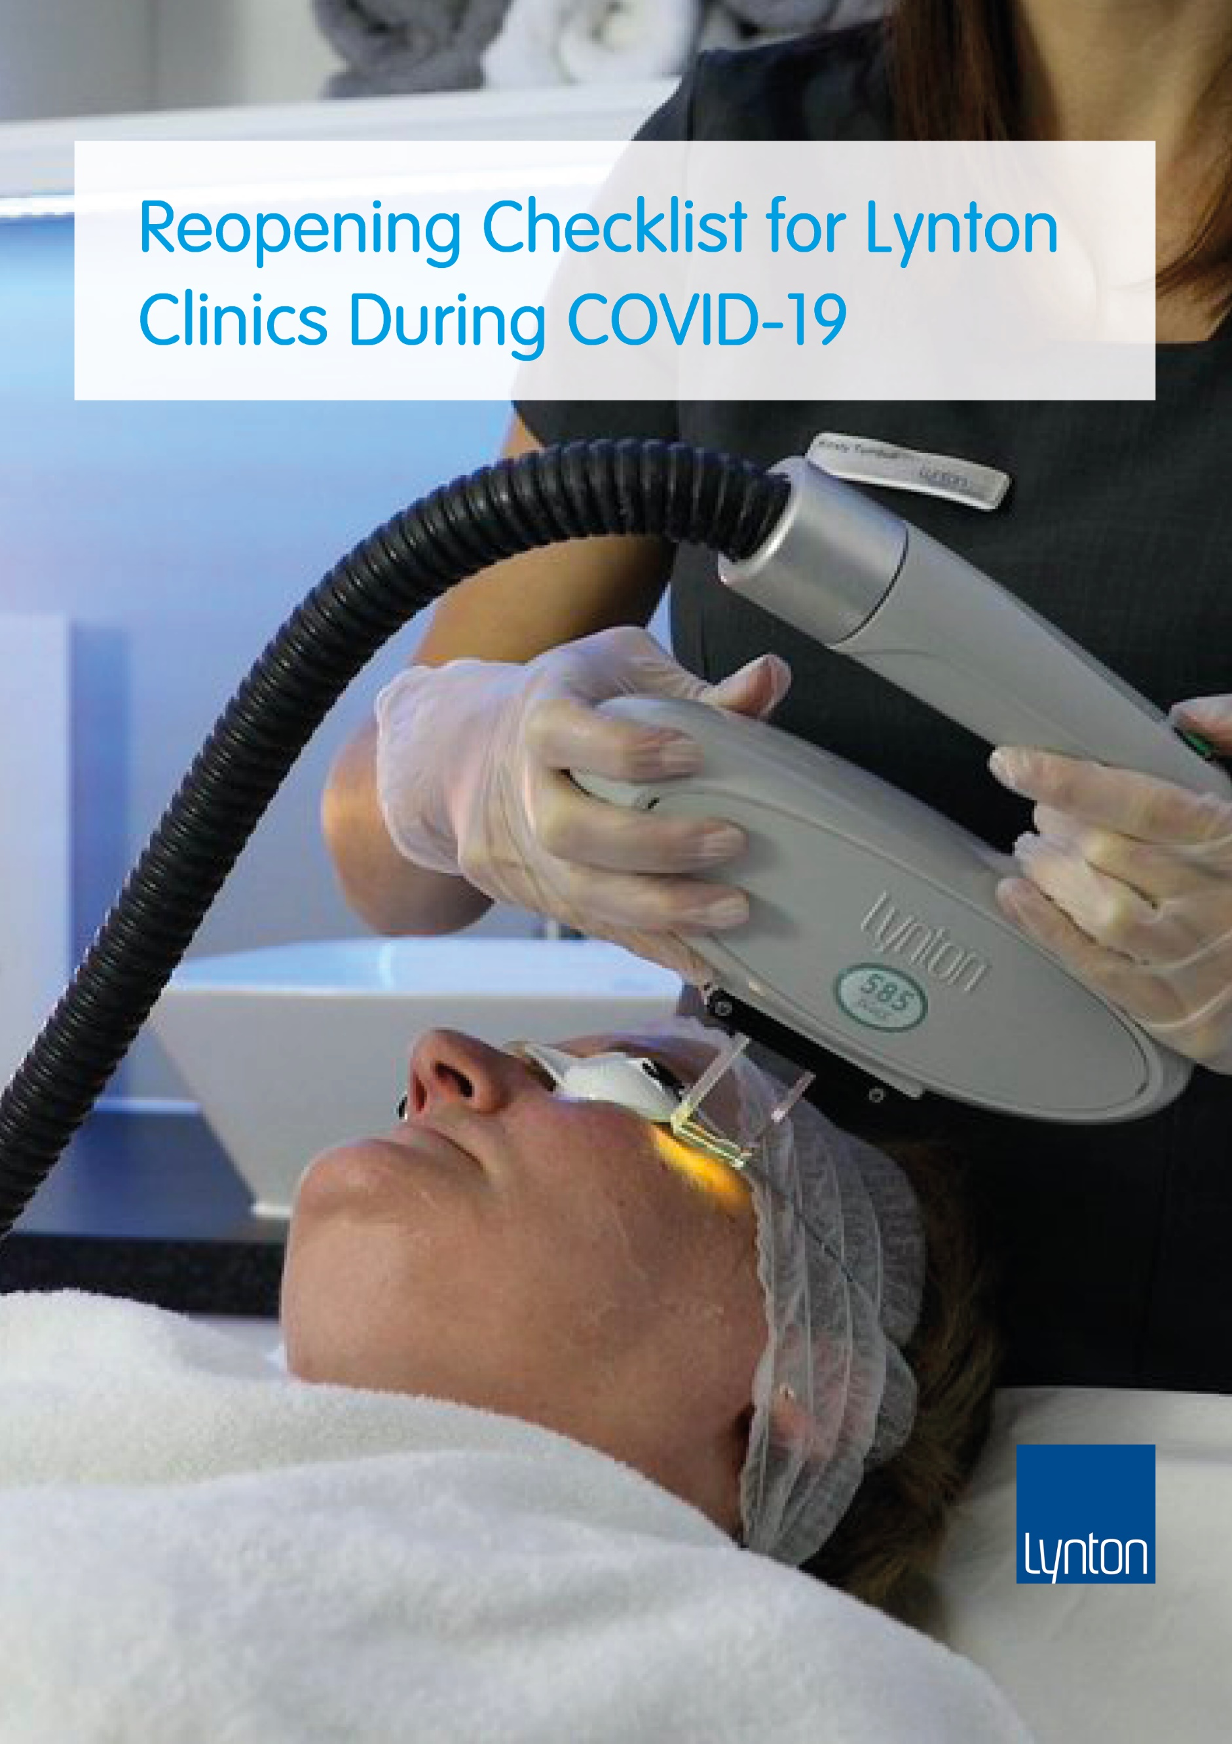
Contents

1. Reopening Guide for Lynton Clinics During Covid-19 2
2. COVID-19 Transmission 2
3. Five Point Checklist 3
4. General Hygiene & Social Distancing Procedures 4
4.1. General Hazard - Contaminated Surfaces 4
4.2. General Hazard and Respiratory Secretions, Coughing and Sneezing 5
5. Room Specific Hygiene and Social Distancing Procedures 5
5.1. The Reception and Waiting Areas 5
5.2. Toilets and Bathrooms 6
5.3. Clinic Office or Staff Rooms 7
5.4. Kitchens 7
5.5. The Treatment Room 7
6. Patient Pre-Treatment Process for Reducing Transmission Risk 8
7. The Treatment 10
8. Personal Protective Equipment (PPE) 12
9. Your Team 12
10. Reducing Transmission from Other Visitors, Goods, materials or merchandise entering the building 13
11. Consideration of items that may be specific to your business 14
12. Insurance 14
13. Disclaimer 14
14. References 15

Reopening Guide for Lynton Clinics During Covid-19

Following the global pandemic of Covid-19 and the subsequent shutdown of non-essential services, aesthetic clinics are now preparing to reopen. Reopening your clinic after COVID-19 will require new and advanced hygiene and social distancing processes and policies to be in place. These will help to make sure that your business can restart safely. This guidance is geared towards a Lynton clinic but may provide useful for any aesthetic clinic.

This document is intended as a guidance checklist of recommended changes to your business processes and services connected to COVID-19. It is important to use this document as guidance only; each business is unique and will require bespoke policies and procedures to be introduced. Practitioners are encouraged to continually review guidance published by Government and industry bodies such as the JCCP (Joint Council for Cosmetic Practitioners), BCAM (British College of Aesthetic Medicine), BACN (British Association of Cosmetic Nurses) and BMLA (British Medical Laser Association).

Special thanks to the JCCP, Consulting Room and the BMLA in the creation of these guidelines.

COVID-19 Transmission

From what we know about other coronaviruses, transmission of SARS-CoV-2 (the virus responsible for COVID-19) is most likely to happen when there is close contact with an infected person. Transmission is thought to occur mainly through respiratory droplets generated by coughing and sneezing, and through contact with contaminated surfaces.

- Direct entry of respiratory droplets into eyes, nose, mouth
- Patient coughs and sneezes onto hands, objects, surroundings
- Touching contaminated objects and then touching mouth, nose and eyes
- The risk of infection transmission increases the longer someone has close contact with an infected person.

Detailed information on transmission and precautions can be found here.

Five Point Checklist

There is currently no Government guidance specifically for the Aesthetics sector on how to prepare your clinic ready for returning to work. There are, however, Government guidelines for other work environments and Lynton advises that (as with these other work environments) you should consider the following five essential steps for preparation to reopen:

- Carry out a COVID-19 risk assessment​ and share results with all employees. An example Risk Assessment can be found here.
- Develop cleaning, handwashing, and hygiene procedures​ in line with guidance.
- Develop social distancing procedures to maintain a 2m distance* in the workplace, where possible (outside the treatment room).
- Where people cannot be 2m apart (during treatments), take all reasonable steps to manage transmission risk.
- Take all reasonable steps to help people work from home.
*2m may be reduced to 1m as the situation improves over time. Monitor Government announcements.

You are currently required to display this poster in your clinic: https://assets.publishing.service.gov.uk/media/5eb97021d3bf7f5d43765cbf/staying-covid-19-secure-accessible.pdf

We advise keeping up to date with Government advice here:
https://www.gov.uk/guidance/working-safely-during-coronavirus-covid-19

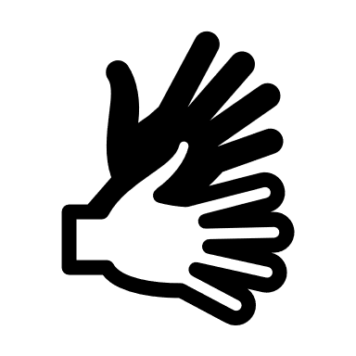
General Hygiene & Social Distancing Procedures

General Hazard - Contaminated Surfaces
- Ensure that all staff have access to soap and hot water handwashing facilities in washroom(s) (which may be bathrooms, toilets or disabled toilets, etc.) and have received training in effective hand washing.
- Make available disposable tissues to cover the nose and mouth during sneezing and coughing. Tissues must be disposed of correctly.
- Discourage the use of the establishment’s washrooms by clients (or thoroughly clean them immediately after they do use them, see later).
- Provide hand-sanitising facilities in the reception/waiting area for the clients to use. If the hand sanitiser is alcohol based it needs to contain >60% alcohol to be effective. Although 70% alcohol hand sanitiser may be even more effective, it will be harsh on hands. Hand hygiene should primarily be done through washing with soap and water and hand sanitiser used as an extra precaution where this is not possible or convenient.
- Put up “Wash your Hands” signs throughout the establishment and “How to Wash your Hands” signs in the washrooms and appropriate areas.
- Increase the regularity and the thoroughness of the cleaning service, particularly for the washrooms (and treatment rooms - see later).
- Surfaces should be sanitised with 70% or above isopropyl alcohol or a disinfectant solution at a dilution of 1000 parts per million (ppm) available chlorine. For items that cannot withstand chlorine-releasing agents, consult the manufacturer’s instructions for a suitable alternative to use following, or combined with, detergent cleaning.
- Where possible introduce touchless operation of usually contact facilities. E.g. touchless hand sanitizers.
- Use waste bins that are either no-touch or foot pedal operated and have hard covers and disposable liners.
- Write up all hygiene and social distancing policies and procedures and make available to all team members.
- Develop a timetable and checklist for all hygiene procedures. e.g. toilet decontamination (see later). Issue to team and ensure everyone knows what needs to be done, by who and when.

General Hazard and Respiratory Secretions, Coughing and Sneezing
- Put up signs to discourage touching the face, how to sneeze correctly, etc., throughout the establishment.
- Utilise Perspex or glass screens in areas where 2m distancing is not possible, such as offices or reception areas. Consulting Room Relaunch is a good place to find these items from reputable suppliers.
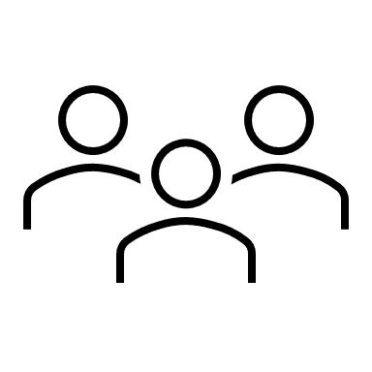
- Introduce Social Distancing measures (see below).

Room Specific Hygiene and Social Distancing Procedures

The Reception and Waiting Areas
- Implement a text or call system so that clients must wait offsite (e.g., in their cars) until the previous client has left. This allows clients to be greeted at the door, given decontamination instructions, and taken straight through to the treatment room.
- Discourage any ‘walk in’ appointments or enquiries.
- Make sure hand sanitiser is available for clients immediately upon entry in the clinic, but NOT on the reception desk/table (i.e. not in the clean area).
- If a client is not wearing their own surgical mask (or better) when they arrive, provide one to wear for the duration of the visit (which includes the treatment itself). Surgical masks from reputable suppliers can be found in Consulting Room Relaunch.
- Stagger appointments to reduce any cross over time between clients in the clinic.
- Depending on the size of the reception/waiting area, set up a system to restrict the clients entering to a number that easily allows social distancing.
- Again, depending on the size of the reception/waiting area, remove all unnecessary chairs.
- Either set up a demarcation line in front of reception (currently at 2m) or install a suitable screen across reception. Designate the reception side of this demarcation as the “clean” area.
- Put up appropriate signage.
- Ensure that the waiting area has no client-accessible POS materials, magazines or brochures in it. Brochures, etc., should only be handed out on request, to take away at the end of a visit. Ideally, issue all paperwork digitally.
- Remove any refreshment-making facilities. The whole idea is to minimise the time a client spends in the premises.
- Set up a procedure for decontaminating surfaces in the waiting area after every client that passes through it.
- Where possible, keep windows open.
- Implement a card-only payment system, contactless if possible. Clean the card reader after every use.
- If cash payments can’t be avoided, implement a hand-washing procedure after handling cash.
- Set up a system where clinic practitioners are not allowed to enter the “clean” areas unless they have changed and washed. Reception staff should also wash their hands before entering their “clean” area. (It is likely that only the largest clinics will have a “clean” area that includes reception, a kitchen, a staff room, etc. Many will only have a reception desk).

Toilets and Bathrooms
Staff and/or clients are particularly at risk of virus transmission by surface contact in the bathroom/toilet areas.
- (If there is more than one) designate which washroom is for staff and which is for clients.
- (If there is only one) discourage (or ban) client-use of the washroom.
- Implement procedures and signage for disinfecting the surfaces in toilets and bathrooms after every use, including door handles, light switches, taps, sink, seat, lid, handle. Toilets should be flushed with the lids closed to prevent aerosolisation.
- Implement a signage system to show a toilet/bathroom is disinfected and ready for use. Amazon and Consulting Room Relaunch have a variety of signs and posters for the workplace.
- Provide paper towels and lined, pedal-operated, hard cover waste bins in the washrooms (disconnect forced-air hand dryers).

Clinic Office or Staff Rooms
Normally, the office would be part of the “clean” zone.
- (If there is enough room) arrange desks to allow social distancing. Use floor-tape if necessary to identify the 2m distance and guide staff movement.
- Prohibit hot-desking.
- Implement procedures for regular cleaning of keyboards, phones and other frequently used items using suitable cleaning solutions.
- Provide sufficient hand sanitiser, tissues, lined pedal-bins, signs, etc.

Kitchens
Normally, the kitchen would be part of the “clean” zone.
- In small kitchens implement a procedure of single person entry (sign needed).
It then depends on how far you want to go, so select from the below at your preference:
- Decommission the kitchen (i.e., disconnect fridge, dishwasher, etc. – all, perhaps, except the kettle).
- Remove shared cooking facilities (microwave, grill, etc.).
- Remove shared crockery and cutlery. Staff have their own mug and spoon.
- Staff bring in their own packed lunches, flasks of tea, coffee, etc.
- Provide suitable decontamination materials, paper towels and lined pedal bin.

The Treatment Room
Practitioners risk being infected by clients from both contact and respiratory emissions because they necessarily have to be very close together, even touching, during a treatment. Treatment rooms are obviously in the “hot” zone.
- (If it doesn’t already have one) if possible, fit a sink into each treatment room.
- (If a sink is not possible) provide hand sanitising facilities in each treatment room.
- (If there is air conditioning) check that the air conditioning does not recirculate air to other rooms in the establishment.
- (If there are windows in the treatment room) open the windows (and keep doors closed) in the intervals between treatments.
- If commercially viable, have extended intervals between treatments. One option would be to arrange treatments such that rooms are alternated (but without moving equipment around).
- Thoroughly disinfect surfaces (including all equipment surfaces) between clients – particularly the treatment couch/bed. Avoid using bed linens and instead use disposable couch roll.
- Remove anything from the treatment room that is not required for the treatment. This will make the regular cleaning much easier and quicker.
- Test equipment before use, some equipment may have been unused during lock-down (10 weeks or longer) and so checks should be performed to ensure correct operation before the day of treatment.
- Do not have fans in the treatment room.
- Depending on the treatment that has just been carried out and the PPE involved, leaving a treatment room will involve various levels of handwashing, clothes changing and PPE cleaning or disposal before a practitioner can re-enter the “clean” zones of the establishment. This will apply to the client as well as the practitioner.
- Ensure that at the end of every day that has involved treatments in a room, that room will be particularly well disinfected, ideally using a combined detergent disinfectant solution at a dilution of 1000 parts per million (ppm) available chlorine. For items that cannot withstand chlorine-releasing agents, consult the manufacturer’s instructions for a suitable alternative to use following, or combined with, detergent cleaning.
- Cleaning of ALL Lynton equipment can be done with alcohol wipes of 70% or above isopropyl alcohol or a disinfectant solution at a dilution of 1000 parts per million (ppm) available chlorine.

Patient Pre-Treatment Process for Reducing Transmission Risk
- Make your consulting and consenting processes as virtual and digital as possible. Any document signing software used (e.g. DocuSign) needs to be legally robust and insurance company recognised.
- Issue as much paperwork as possible digitally, such as medical history, consent, pre- and post-treatment guidelines, receipts, etc.
- Medical history and COVID-19 screening questionnaire to be issued digitally and returned signed copies to be reviewed ahead of the Virtual Consultation. Patient screening should include symptoms listed by the NHS. Other useful screening questions provided by the JCCP can be found here.
- We do not advise adding in extra informed consent for COVID-19 but advise you to check if it is a requirement of your insurance provider.
- Should a client present who you suspect has COVID-19 symptoms, follow the guidance from the JCCP
- Consider a virtual consultation process using legally robust and encrypted video calling software such as Microsoft Teams. Many providers of online booking systems such as Pabau and Ovatu offer a built-in video call and paperless consenting process. If using these, or any other services, check they are GDPR complaint.
- Include in the consultation and booking processes an instruction that clients must attend for treatments unaccompanied and with a bare minimum of personal possessions.
- Implement a text or call system so that clients must wait offsite (e.g., in their cars) until the previous client has left.
- Include in the consultation and booking processes a notification to clients that when they attend for treatments they will be expected to wash/sanitise their hands-on arrival, and that they will be expected to follow social distancing requirements.
- Provide clear guidance on social distancing and hygiene to people both on arrival (for example, signage or visual aids) and before arrival (for example, by phone, on the website or by email). Several examples of client communication documents can be found in Consulting Room Relaunch.
- Include in the consultation and booking processes a notification to clients that when they attend for treatments, they will be expected to wear suitable PPE, which will be provided for them (if they don’t bring their own).
- The day before their appointment clients should be contacted for a pre-treatment COVID -19 screening questionnaire.

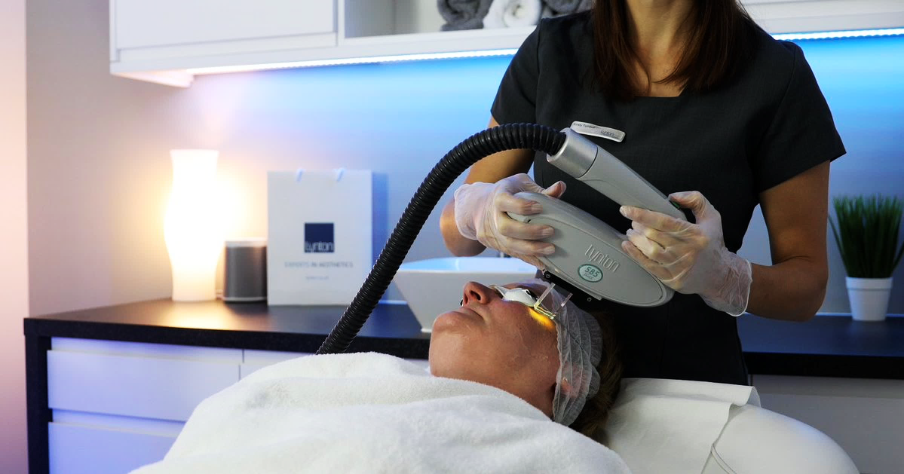

The Treatment
- Consider limiting treatment times to 1 hour or less to reduce transmission load.
- Consider increased intervals between treatments times to allow for advanced hygiene procedures.
- Implement a clothes policy whereby a practitioner comes to work in normal clothes, changes into a Clinic/Salon uniform (or, even better, scrubs) before doing any treatments, and then, at the end of the day, changes back into their normal clothes and the Clinic/Salon uniform (or scrubs) are washed. Practitioners will not go home in a uniform that they have worn all day. This will involve designating a particular room (maybe an unused treatment room, or a washroom) as a changing room. Only one person will be allowed to use the room at any one time. Make out designated spaces / lockers per person to store personal items. If uniforms are taken offsite to be washed, they should be transported in a plastic bag and then washed separate to other laundry at 60 degrees Celsius or above. Gloves should be used to insert laundry into washing machines.
- Ensure that the practitioner’s personal possessions (such as handbags, mobile phones, etc.) are not taken into the treatment rooms. This may involve installing lockers, lockable cupboards, etc.
- For any treatment, ensure that the practitioner is not wearing jewelry, nail polish or other non-essential accessories.
- For any treatment, the practitioner will wear single-use nitrile gloves (or similar).
- For any treatment, the client will wear a disposable surgical mask (to help protect the practitioner).
- Pre-treatment skin cleansing should be meticulous.
- For any laser or IPL treatment, ensure that the Laser/IPL protective eyewear to be worn by the client will be cleaned with suitable anti-viral wipes in front of the client before the treatment starts. The practitioner’s Laser/IPL protective eyewear will be similarly cleaned between treatments.
- For any laser or IPL treatment, the practitioner will wear either a single-use or a pre-cleaned reusable visor over their Laser/IPL protective eyewear.
- For any laser or IPL treatment, the practitioner will wear a disposable apron or gown (even if they are in scrubs).
- For any laser or IPL treatment, consider the use of a smoke evacuation system. Such systems should be fitted with a ULPA filter, not just a HEPA filter. The system should be serviced as per the manufacturer’s instructions and must be used properly (which may involve training). Further information on smoke evacuators can be found here. Lynton’s recommended smoke evacuator can be found here.
- For any laser or IPL treatment limit the use of chilled air blowers to cool the treatment site. Consider the use of cooled gels or icepacks for skin cooling purposes. Where chilled air is necessary it is advisable to complete at the end of the day giving your room time to ventilate.
- For any laser or IPL treatment consider the use of gel, hydrogel packs or cling film to reduce the amount of plume or tissue splatter. Gel should be considered clinical waste and disposed of accordingly.
- For any treatment on a part of the client’s body below the clavicle, the practitioner will wear a disposable FFP2 (N95 or KN95) Face Mask.
- For any treatment on a part of the client’s body above the clavicle (e.g., on their face), the practitioner will wear an FFP3 (N99 or KN99) Face Mask (valved or unvalved, disposable or pre-cleaned reusable) that needs to have been correctly fitted. One of the reasons for the higher level of protection is because it may be necessary to ask your client to temporarily move their surgical face mask to allow you to work around the mouth (such as in laser hair removal on the lip or skin tightening RF procedures).
- Ensure that all virus-related PPE is securely stored in the Treatment Rooms, so that it can be put on in the Treatment Room immediately before a treatment starts.
- Ensure that practitioners have the facility to wash their hands in soap and water immediately before putting on gloves and other PPE before a treatment and washing them after taking off the PPE and gloves after a treatment. This why it is a good idea to have a sink in the Treatment Room, with paper towels and a lined pedal bin.
- Clients to be escorted from the premises, where possible, by staff members with appropriate social distancing.

Personal Protective Equipment (PPE)

- Use PPE that is appropriately CE-marked. It is recommended to use this resource for securing PPE such as visors, aprons and FFP2 and FFP3 masks.
- Ensure that practitioners have the facility to wash their hands in soap and water immediately before putting on gloves and other PPE before a treatment and washing them after taking off the PPE and gloves after a treatment. This why it is a good idea to have a sink in the Treatment Room, with paper towels and a lined pedal bin.
- Ensure that all practitioners have been trained in fitting PPE, particularly if FFP3 masks are being used for treatments above the client’s clavicle (donning and doffing PPE). Further information on FIT testing can be found here.
- PPE should be disposed of appropriately. It should be placed in non-touch or pedal bins with hard covers and disposable liners and disposed of as clinical waste.

Your Team
- Before returning to work, any staff member will be asked to self-certify that they or any member of their household are not affected by the virus. If they can’t do this, they will not be allowed to return to work.
- Before returning to work, any staff member will be asked to self-certify that they are not in the Clinically Vulnerable and the Extremely Clinically Vulnerable categories. If they are in either of these categories, they will not be allowed to return to work.
- Staff will be told that they are obliged to immediately inform their Line Manager if they become aware that they are affected by the virus or a member of their household is affected by the virus. Similarly, they will be obliged to immediately tell their Line Manager if they learn that they have become either Clinically Vulnerable or Extremely Clinically Vulnerable (e.g. if they have just learnt that they are pregnant).
- For large teams, implement a Rota system, staggering hours of work and keeping workers in groups to reduce contact across the team.
- Develop and circulate all Hygiene and Social Distancing policies and procedures to the team before they return to work.
- Ask team members to confirm in writing that they have read and understood them.
- Arrange Staff Training, ideally delivered remotely. Topics covered might include “How to host clients and/or visitors”, “Donning and doffing PPE”, “hand hygiene”, “virtual consultations”, etc.
- A draft of the Risk Analysis will be circulated, and staff invited to contribute towards a final version.

Reducing Transmission from Other Visitors, Goods, materials or merchandise entering the building
- Discourage visitors.
- If possible, don’t let any visitors come any further than the waiting area. If visitors must come further than the waiting area, ensure that they wash their hands first, and then provide them with surgical masks.
- Keep a record of all visitors (it is assumed here that all clients are also automatically being logged).
- If possible, don’t even let delivery people into the building. As with most home deliveries, it is best if they can leave the goods outside and ring the bell to let you know.
- In the same way as with clients, clean the areas that visitors have been after they have left.
- Provide hand sanitising facilities and a lined pedal bin at the point of entry (i.e. the waiting area).
- If possible, unwrap items outside the building or, at least, in the waiting area. Then wash hands.
- Consider reducing the frequency of deliveries by ordering larger quantities.
- If possible, and where relevant, have only ONE person dealing with a delivery.
- Prohibit non-business deliveries.

Consideration of items that may be specific to your business
Examples such as:
- Stop doing consultations in Treatment Room 1. Remove the desk and PC.
- Change the horizontal Venetian blind in Treatment Room 2 (it’s going to be hard to keep clean).
- Decommission the fan in the wall of Treatment Room 3 that just blows contaminated air out into the reception area.

Insurance

It is advisable to check with your insurance provider that your insurance for all treatments is still valid and covers everything. We recommend sharing risk assessments, policies, and procedures with your insurance provider. Review any new endorsements that add to your policy, particularly on renewal. It would be worth reviewing this on a regular basis.

Disclaimer

This document has been produced as an example of preferred practice guidelines for a Lynton clinic. It does not supersede or provide an alternative to government or healthcare regulatory body advice. Practitioners and employers are encouraged keep up to date with, and employ, government advice or healthcare regulatory body advice pertaining to Aesthetic Clinics and general workplace guidance. Lynton cannot be held responsible for any of the outcomes in following this guidance.

References

- https://www.gov.uk/government/publications/wuhan-novel-coronavirus-infection-prevention-and-control
- https://assets.publishing.service.gov.uk/government/uploads/system/uploads/attachment_data/file/886668/COVID-19_Infection_prevention_and_control_guidance_complete.pdf
- https://www.gov.uk/guidance/working-safely-during-coronavirus-covid-19
- https://www.jccp.org.uk/ckfinder/userfiles/files/Preparing%20for%20return%20to%20practice%20June%20update%20v2.pdf?utm_source=website&utm_medium=PR&utm_campaign=COVID-19
- https://www.nhs.uk/live-well/healthy-body/best-way-to-wash-your-hands/
- https://www.england.nhs.uk/south/wp-content/uploads/sites/6/2017/09/catch-bin-kill.pdf
- https://www.consultingroom.com/relaunch/home.php
- https://www.bmla.co.uk/wp-content/uploads/2020/BMLA-guidance.pdf
- https://assets.publishing.service.gov.uk/government/uploads/system/uploads/attachment_data/file/877658/Quick_guide_to_donning_doffing_standard_PPE_health_and_social_care_poster__.pdf

EXPERTS IN AESTHETICS

Head Office
Unit 9D, Lynton House, Manor Lane, Holmes Chapel, Cheshire
CW4 8AF, United Kingdom

Tel: +44 (0)1477 536 977
Fax: +44 (0)1477 536 978
info@lynton.co.uk

Departmental Direct Dial

01477 536970 | Sales
(New System Enquiries)
01477 536976 | Service (Parts & Lamps)
01477 536972 | Accounts (suppliers)
01477 536973 | Accounts (customers)
01477 536975 | Marketing

Follow us on:

#weuseLynton

